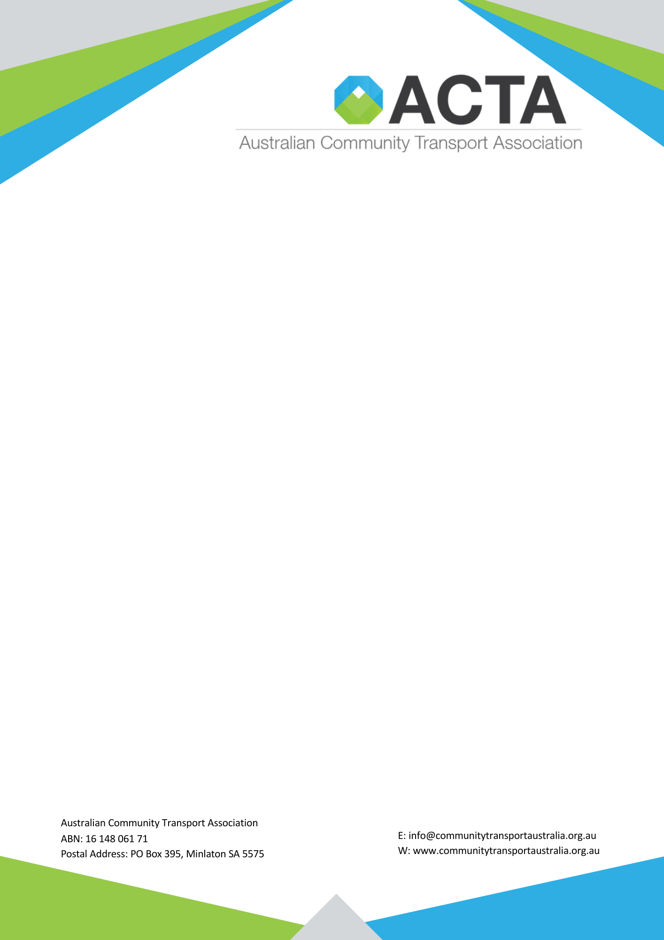

[Date]
The Hon/Dr/Mr/Ms [MP NAME] MP
[Electorate / Position]
[Address]

Dear [MP NAME],
Re: Help us secure a sustainable future for CHSP and community transport
Firstly, thank you for your work and advocacy on behalf of older Australians and the communities you represent.
We also acknowledge the Australian Government for listening to the concerns raised by older Australians, families, providers and the broader community, and for its decision to extend the Commonwealth Home Support Programme (CHSP) until 30 June 2029.
For our sector, this is an important and welcome decision. It provides greater certainty for older Australians who depend on CHSP and for the organisations, employees and volunteers who support them every day. But 2029 is not the finish line.
Minister for Aged Care and Seniors, the Hon Sam Rae MP, has indicated that consultation and co-design on the long-term future of CHSP will begin with the Department of Health, Disability and Ageing next month.
That means decisions about the future of CHSP, including how services are funded and designed are about to begin.
As a community transport provider supporting older Australians across [ELECTORATE / REGION], we are asking for your help to ensure community transport has a strong voice in that process, and the Australian Community Transport Association (ACTA), the national peak body for community transport in Australia covering all states and territories, is at the table where those decisions are made. We are asking you to support three priorities.
1. Put ACTA and community transport at the CHSP co-design table
Community transport is much more than getting someone from A to B. It allows older Australians to maintain their independence and remain living safely at home longer.
ACTA has already undertaken substantial work with community transport providers across metropolitan, regional, rural and remote Australia to understand what needs to be protected and what needs to change within CHSP.

Through the National Community Transport Pricing Model (NCTPM), ACTA has examined many of the issues that will be central to successful CHSP co-design. Importantly, the Independent Health and Aged Care Pricing Authority’s (IHACPA) recent pricing advice for Support at Home (May 2026) strongly aligns with the pricing ranges identified through the NCTPM, including its recognition of distinct pricing arrangements for Direct and Indirect Transport.
Government has committed to co-design. We ask you to support ACTA having a meaningful and ongoing place at that table, bringing both the evidence and the experience of community transport providers into the decisions that will shape CHSP beyond 2029.
2. Deliver fair pricing for community transport
The future CHSP must recognise what community transport truly costs to deliver.
A short metropolitan journey cannot be treated in the same way as a long-distance regional journey requiring significant driver time, passenger assistance, accessible vehicles and unavoidable return travel. Informed by the Re-abling Mobility: The Role of Community Transport report, prepared externally by Movement Place and Consultancy (Attachment 1), and the National Community Transport Pricing Model (NCTPM) (Attachment 2), delivered by Adelaide University. The NCTPM extends beyond pricing, providing an evidence base for broader policy reform.
ACTA’s position is that pricing must recognise differences between Direct and Indirect Transport, with Direct Community Transport funded at a higher rate to reflect the infrastructure, workforce, service quality and person–centred supports required to deliver it.
Through the NCTPM, ACTA has developed an evidence base that considers the real costs of delivering community transport.
We ask Government to work with ACTA to establish a transparent, nationally consistent and evidence-based pricing framework.
3. Close the funding gap and establish sustainable indexation
Providers are facing sustained increases in wages, fuel, vehicles, insurance, technology adoption and maintenance.
Over recent months, ACTA has undertaken extensive consultation with the sector, receiving well over 100 responses from community transport providers and stakeholders. The message has been remarkably consistent: the current funding and contracting arrangements are no longer keeping pace with the realities of service delivery.
ACTA's work indicates that indexation of approximately 5.8% would be required in 2026–27 simply to maintain current service levels. Against the announced CHSP indexation rate of 2.8% for 2026–27, this represents a shortfall of approximately 3 percentage points, effectively reducing funding in real terms and placing further pressure on organisations already operating within tight contractual funding arrangements. The combination of inadequate indexation and the absence of meaningful growth funding, particularly for community transport services, has effectively reduced service availability over recent years.
ACTA is therefore calling for a fit-for-purpose hybrid indexation model that better reflects the real cost drivers of community transport.
We cannot continue asking providers to do more with less. We need your voice!
As our local representative, we respectfully ask you to raise these priorities with Minister Rae and the Australian Government, and advocate for:
ACTA and community transport to have a genuine seat at the CHSP co-design table; fair and evidence-based pricing for community transport; and sustainable funding and indexation that reflect the real cost of delivering services.
ACTA and its members are ready to work constructively with Government. We have the evidence, the experience and, most importantly, the voices of the communities we serve.
Keeping CHSP until 2029 is an important win. Now we need to build a CHSP that is properly funded, locally responsive and sustainable well beyond 2029.
I would welcome the opportunity to speak with you about what these issues mean for older Australians and community transport services in [ELECTORATE / COMMUNITY].
Kind regards,
[NAME]
[POSITION]
[ORGANISATION]
[PHONE]
[EMAIL]

